Name: P V GIRIDHAR
Reg. No: 1972260022
Exercise 2
AIM:
To write a Python program using NumPy to find the average price of all the products sold in the past month from a 3x3 sales matrix in which each row represents a different product.
ALGORITHM:
Step 1: Start.
Step 2: Import the NumPy library.
Step 3: Create the 3x3 matrix sales_data (each row represents a different product).
Step 4: Calculate the mean of all the elements of the matrix to get the average price of all the products sold.
Step 5: Calculate the mean of each row to get the average price of each product.
Step 6: Display the matrix, the overall average price and the average price of each product.
Step 7: Stop.
PROCEDURE:
- Import the NumPy library as np.
- Create the 3x3 array sales_data using np.array(), where each row represents a different product.
- Calculate the average price of all products sold using np.mean(sales_data), which averages all 9 elements.
- Calculate the average price of each product separately using np.mean(sales_data, axis=1) (row-wise).
- Print the matrix, the overall average price and the average price of each product.
INPUT AND OUTPUT:
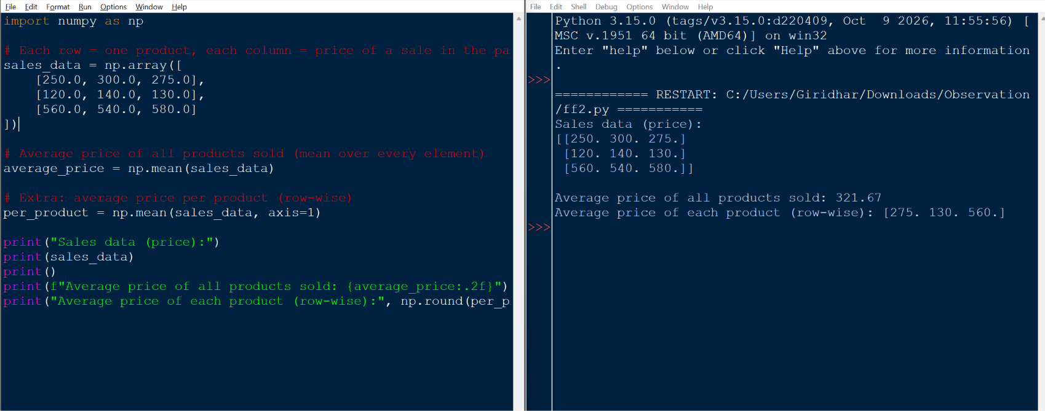
RESULT:
The average price of all the products sold in the past month is 321.67. The row-wise averages for the three products are 275, 130 and 560. Thus the program was executed successfully and the output was verified.

